**Exercise 1: Ranking and Window Functions**

**QUERY:**

**Create Schema**

CREATE TABLE Categories (

CategoryID INT PRIMARY KEY,

CategoryName VARCHAR(100)

);

CREATE TABLE Products (

ProductID INT PRIMARY KEY,

ProductName VARCHAR(100),

Price DECIMAL(10, 2),

CategoryID INT FOREIGN KEY REFERENCES Categories(CategoryID)

);

**Insert Sample Data**

INSERT INTO Categories (CategoryID, CategoryName) VALUES

(1, 'Home Appliances'),

(2, 'Stationery'),

(3, 'Footwear');

INSERT INTO Products (ProductID, ProductName, Price, CategoryID) VALUES

(1, 'Microwave Oven', 250.00, 1),

(2, 'Refrigerator', 900.00, 1),

(3, 'Vacuum Cleaner', 450.00, 1),

(4, 'Air Purifier', 500.00, 1),

(5, 'Notebook Pack', 12.00, 2),

(6, 'Fountain Pen', 30.00, 2),

(7, 'Sketchbook', 18.00, 2),

(8, 'Running Shoes', 75.00, 3),

(9, 'Loafers', 95.00, 3),

(10, 'Boots', 120.00, 3),

(11, 'Socks', 8.00, 3);

**Use Ranking Functions**

SELECT

c.CategoryName,

p.ProductName,

p.Price,

ROW_NUMBER() OVER (PARTITION BY c.CategoryID ORDER BY p.Price DESC) AS RowNum,

RANK() OVER (PARTITION BY c.CategoryID ORDER BY p.Price DESC) AS RankNum,

DENSE_RANK() OVER (PARTITION BY c.CategoryID ORDER BY p.Price DESC) AS DenseRankNum

FROM Products p

JOIN Categories c ON p.CategoryID = c.CategoryID;

**OUTPUT:**

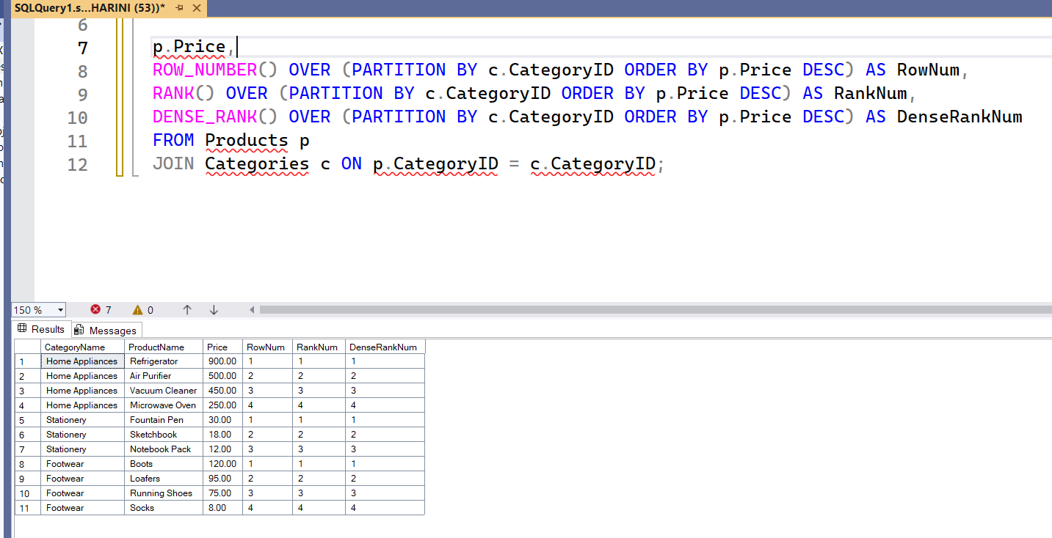

**Exercise 1: Create a Stored Procedure**

**QUERY:**

**Create the Employees Table**

CREATE TABLE Employees (

EmployeeID INT IDENTITY(1,1) PRIMARY KEY,

FirstName VARCHAR(50),

LastName VARCHAR(50),

DepartmentID INT,

Salary DECIMAL(10,2),

JoinDate DATE

);

**Create Stored Procedure**

CREATE PROCEDURE sp_InsertEmployee

@FirstName VARCHAR(50),

@LastName VARCHAR(50),

@DepartmentID INT,

@Salary DECIMAL(10,2),

@JoinDate DATE

AS

BEGIN

INSERT INTO Employees (FirstName, LastName, DepartmentID, Salary, JoinDate)

VALUES (@FirstName, @LastName, @DepartmentID, @Salary, @JoinDate);

END;

**Execute Insert Employee Procedure**

EXEC sp_InsertEmployee

@FirstName = 'Alice',

@LastName = 'Smith',

@DepartmentID = 2,

@Salary = 60000.00,

@JoinDate = '2024-05-10';

**Create Stored Procedure to Retrieve Employees by Department**

CREATE PROCEDURE sp_GetEmployeesByDepartment

@DepartmentID INT

AS

BEGIN

SELECT EmployeeID, FirstName, LastName, DepartmentID, Salary, JoinDate

FROM Employees

WHERE DepartmentID = @DepartmentID;

END;

**OUTPUT:**

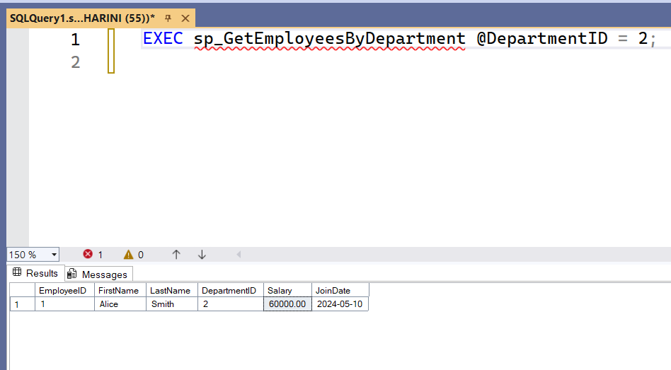

**Exercise 5: Return Data from a Stored Procedure**

**QUERY:**

**Create Stored Procedure to Count Employees**

CREATE PROCEDURE sp_CountEmployeesByDepartment

@DepartmentID INT

AS

BEGIN

SELECT COUNT(*) AS TotalEmployees

FROM Employees

WHERE DepartmentID = @DepartmentID;

END;

**Execute Count Employees by Department**

EXEC sp_CountEmployeesByDepartment @DepartmentID = 2;

**OUTPUT:**

